- How is the load carrying capacity related to selecting a robot for a given application? What is the impact of the mass of the end effector?
Answer:
Relation to robot selection: The robot must be chosen so its payload capacity (rated maximum load) exceeds the required load plus a safety margin. Required static capacity determines actuator torque/gearbox sizing, and required dynamic capacity determines motor power and thermal capability (to accelerate/decelerate the payload without overheating).
Important checks: check reach × payload (torque increases with reach), inertia of payload (affects dynamic torque), required repeatability/accuracy under load, and duty-cycle (continuous vs intermittent work).
Impact of end-effector mass:
- Increases required motor torque (especially for joints near base) and may reduce maximum reachable payload due to moment arms.
- Increases system inertia → slows acceleration, increases settling time, may reduce control bandwidth and accuracy.
- Raises structural/stiffness requirements (deflection under gravity), which can degrade repeatability.
- Safety margin: design payload rating should include end-effector mass + workpiece mass + tooling + cabling (~10–30% margin typical).
- The petrol tank of a motorcycle must be spray painted by a robot. The tank is a three-dimensional object with curved surfaces about all axes with a half tear drop shape. The spray nozzle must always be perpendicular to the surface at a distance of 100 mm. Determine the no of degrees of freedom required by the robot. Justify your answer.
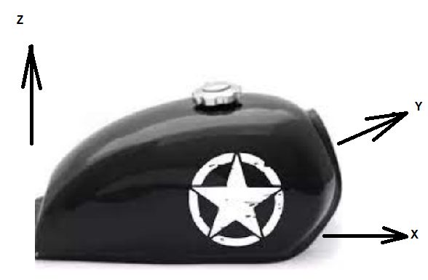

Answer:
Degrees of freedom for painting a 3-D teardrop tank, nozzle perpendicular at 100 mm
Assumptions & reasoning (brief):
- The spray nozzle must be located over each surface point (3 spatial coordinates) and oriented so the nozzle axis equals the surface normal (two orientation constraints — pitch & yaw). The nozzle must also maintain a fixed standoff distance (100 mm) along its axis — that distance is enforced by the position constraint, not an extra DOF. Rotation of the nozzle about its own axis (roll) does not change perpendicularity or distance (unless the nozzle has an orientation-sensitive pattern), so it is not strictly required.
Conclusion: Minimum required DOF = 5.
- 3 DOF for positioning the nozzle tip in space (x,y,z), and 2 DOF to align nozzle axis with the surface normal (pitch & yaw).
- A 6-DOF robot gives full orientation freedom (useful in practice for tooling clearances or to adjust nozzle roll), but 5 DOF is the theoretical minimum if roll is not required.
- Analyze the mechanism given in the figure and determine the degrees of freedom.

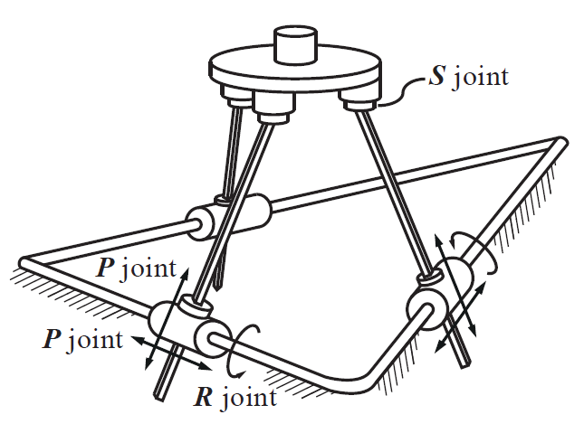

Answer:
Analyze mechanism in the figure and determine DOF
Method (short and exactly what you’d use):
For a planar mechanism use Kutzbach (Grübler) formula:
F=3(n−1)−2jF = 3(n-1) - 2jF=3(n−1)−2j
where nnn = number of links (including ground), and jjj = number of one-DOF lower pairs (pin or slider). If the mechanism has higher-pair joints or multi-DOF joints, include them accordingly (use their DOF in place of 1). For spatial mechanisms use the spatial form F=6(n−1)−∑fiF = 6(n-1) - \sum f_iF=6(n−1)−∑fi​ where fif_ifi​ are joint freedoms.
Application / example:
- If the figure is a standard four-bar (4 links including ground, and 4 pin joints): n=4, j=4n=4,\ j=4n=4, j=4 ⇒
F=3(4−1)−2(4)=9−8=1F = 3(4-1) - 2(4) = 9 - 8 = 1F=3(4−1)−2(4)=9−8=1 → 1 DOF (common result).
Note / result for your figure: I do not have the image in this message. Use the above formula: count links nnn (ground included) and count joints jjj (pin =1 DOF each; slider =1 DOF). Plug into F=3(n−1)−2jF=3(n-1)-2jF=3(n−1)−2j for planar mechanisms and compute the numeric DOF. If you paste the figure/the counts I’ll compute immediately.
- Assign the coordinate frames and write the forward kinematics equation for the 6 dof manipulator for the shown home position (figure 3), Write the equations for $T_{0}^{1}$, $T_{1}^{2}, T_{2}^{3},$ $T_{3}^{4},$ $T_{4}^{5}$ and$T_{5}^{6}$. (General Equations are sufficient - Matrix Expansion is not required).
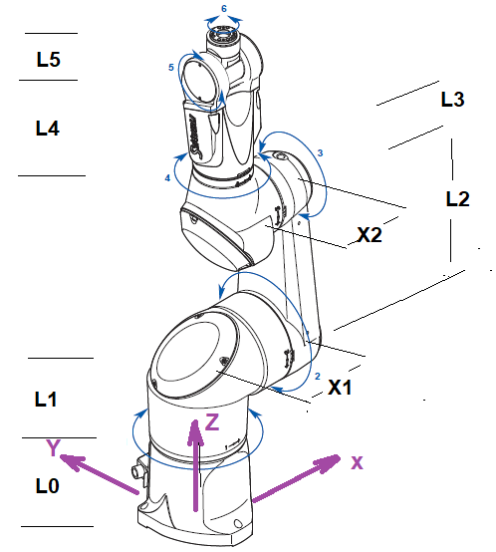

Assign frames & forward kinematics for a 6-DOF manipulator (home position). Provide T01, T12, …, T56T_0^1,\;T_1^2,\;\dots,\;T_5^6T01​,T12​,…,T56​. (General equations sufficient.)
Assumptions: Use standard Denavit–Hartenberg (DH) convention. Label links 1..6 and let DH parameters be (ai,αi,di,θi)(a_i,\alpha_i,d_i,\theta_i)(ai​,αi​,di​,θi​) where θi\theta_iθi​ is joint variable for revolute joints and did_idi​ for prismatic joints. (You asked for general equations — matrix expansion not required.)
DH homogeneous transform (standard):
For link iii (transform from frame i−1i-1i−1 to iii):
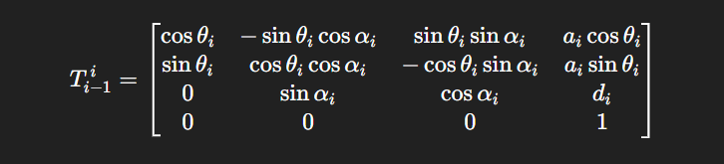
Answer (list the six transforms):
Write each transform Ti−1 iT_{i-1}^{\,i}Ti−1i​ using the above template with the corresponding DH parameters for that joint
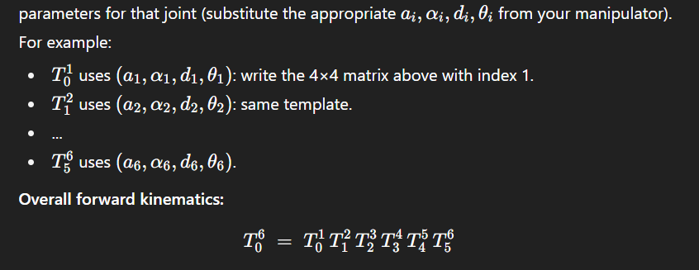
(Compute by multiplying the six DH matrices. Since you requested general equations only, explicit expansion is not required.)
- How is a drive system selected while designing a robot?
Answer:
Key points (concise):
- Requirements first: determine payload, peak torque, continuous torque, speed, acceleration, bandwidth, precision/step resolution, and duty cycle.
- Match motor type to need: (servo motors for high-performance position control, stepper for lower-speed open-loop, BLDC/AC for high power).
- Gearbox selection: choose gearbox ratio and type (harmonic, planetary, cycloidal) to meet torque, backlash, stiffness and inertia matching.
- Control & feedback: ensure encoder/resolver type provides required resolution; closed-loop control must meet bandwidth.
- Mechanical & thermal constraints: size, mounting, cooling, safety factor and life; choose drives that meet electrical supply and safety standards.
- List the steps in using a polygon to determine the Chebyshev’s spacing of n number of accuracy points. Comment of the spacing of the points.
Answer:
Steps (short):
- Draw the desired workspace region/profile in which accuracy is to be evaluated.
- Inscribe a Chebyshev polygon (usually a convex polygon approximating the workspace boundary) such that its vertices bracket the workspace extremes in the direction of interest.
- Project the polygon edges onto the axis (or curve) where accuracy points are needed.
- Compute the Chebyshev nodes (roots or extrema of Chebyshev polynomial) mapped into the polygon-projected interval to obtain nnn points; these minimize the maximum interpolation error.
- Place the nnn accuracy test points at these mapped node positions (and translate back to workspace coordinates).
Comment on spacing: Chebyshev spacing clusters points more densely near the ends (boundaries) of the interval and more sparsely in the center — this minimizes the maximum error (minimax property) and is preferred when endpoint accuracy is most critical.

- Find the variables θ1, θ2 and d3 for the given arm for the target point P (650,250,350), if X1= 100mm X2 = 150mm, L1 = 400mm.
I must state assumptions (explicit): the figure is not present here, so I assume a common R-R-P arm topology used in many exam problems:
- Joint 1: revolute about base Z (azimuth) → θ1\theta_1θ1​.
- Joint 2: revolute in the vertical plane (shoulder pitch) → θ2\theta_2θ2​.
- Joint 3: prismatic (extension along the forearm direction) → d3d_3d3​.
- Link geometry: base height/offset L1L_1L1​ raises the shoulder joint; planar link lengths in the shoulder-forearm direction are X1X_1X1​ (shoulder link) and X2X_2X2​ (forearm fixed portion). The prismatic joint extends from the forearm tip along the current forearm direction by amount d3d_3d3​. This is a standard R-R-P serial chain interpretation.
Solution approach (clear steps) — compute θ1\theta_1θ1​ numerically and give formulas for θ2,d3\theta_2,d_3θ2​,d3​:
